**GLUTEN-FREE DIET SIDE EFFECTS AND TREATMENT**

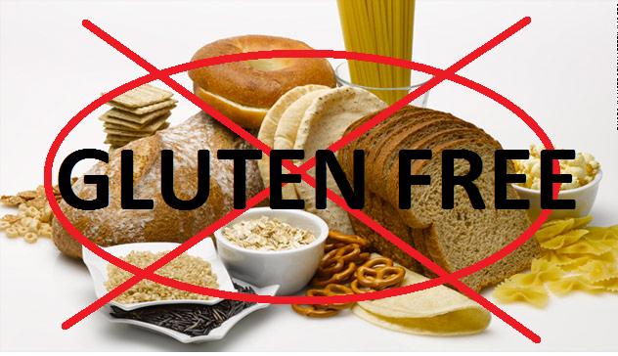We all have been growing hearing this- “Balanced diet is key to a healthy life”. What’s a balanced diet? A diet having adequate amounts of all nutrients required by our body. Vitamins, minerals, carbohydrates, fats, proteins being some of them. Not to eat everything in one meal but make a diet plan and have meals containing equal proportions of essential nutrients. Gluten is another fulfilling requirement of our body. Then, why choose a gluten-free diet and what are the gluten-free diet side effects?

**What composes a gluten-free diet?**

Gluten is a protein composite usually found in grains like wheat, barley, rye and triticale. It is composed of two main proteins, namely, glutenin and gliadin.

Gluten provides food items elastic shape and smooth texture. This protein grows like a web connecting every molecule and sticks together, spaces filled with air. Gluten-free diet side effects are usually because of a processed food diet which claims to be gluten-free and healthy. Actually, starch or flour is replaced with gluten in most packed food items and people consider it healthy!

**Is gluten-free diet unhealthy?**

Gluten-free diets are usually fad diets to flush off water weights from the body in regular instalments. But there are some associated negatives of gluten-free diet and some disadvantages of gluten-free diet that must be kept in mind while going gluten-free!

Problems with gluten-free diet are-

* The natural gluten containing food is processed and then packed eliminating essential nutrients along with gluten from the diet.
* It is only recommended to have a gluten-free diet if you are allergic to gluten or have gluten sensitivity. For the rest population, gluten-free diet means a colour missing out in a rainbow routine.
* Drawbacks of gluten-free diet include lack in fiber, iron, zinc, folate, thiamine, vitamin B12, calcium, phosphorus and the list goes on.

Gluten-free diet side effects overweigh its benefits!

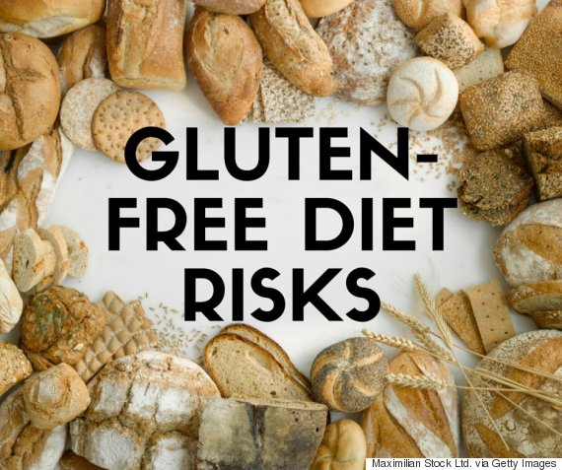

**Why gluten-free diet is bad?**

Our body works like a power engine machine which runs on fuel we provide in terms of food we eat. You must have heard about disadvantages of gluten-free diet in words of disadvantages of processed food. The more we stick to nature the more it is beneficial. Similarly, a natural diet is beneficial in its own terms!

**But why is gluten-free diet unhealthy and what are disadvantages of gluten-free diet?**

Problems with gluten-free diet? We often get swayed away with promos mentioning gluten-free diet and consider it a healthy option for us. But what about gluten-free diet side effects? What exactly the scenario is? We are leading a life where any person with huge limelight attracts us more than a huge thought. We must negotiate on our levels to understand what’s real and what’s fake! Drawbacks of gluten-free diet implants the same point effectively! And gluten-free diet side effects follow.

**What to eat then?**

* Don’t run for processed gluten-free food if you are not gluten sensitive or prone to gluten caused diseases.
* Choose natural fruits and vegetables, seeds, beans, dairy products, poultry, fresh eggs etc.

Studies show why gluten-free diet is bad and what are negatives of gluten-free diet plan.

* Gluten avoids excess of calories to pile up as it has low in calories.
* Gluten reduces risk of colorectal cancer and heart diseases.
* It lowered risks of type 2 diabetes too.

Above facts are based on research and surveys on gluten-free diet side effects done with people on gluten-free diet and people following a gluten containing diet.

If these outcomes prove to be so effective, why not add gluten to our diets?

**What are gluten-free diet side effects?**

There are various gluten-free diet side effects which can be set aside by taking a balanced diet, also giving us a reason why gluten-free diet is bad for our health!

* Constipation
* Diarrhoea
* Gas
* Weight changes
* Fibre deficiency

Above drawbacks of gluten-free diet are major issues to ponder upon. To our rescue, natural food is available everywhere. Grab some healthy feast for yourself and don’t believe on ‘gluten-free means healthy’ quote if you find it somewhere!